**Navigate Between Screens using React Navigation V5 in React Native**

**How to Navigate Between Screens**

React Navigation provides all the different type of navigator like

1. Stack navigator: For the simple screen switching
2. Drawer Navigator: To create Navigation Drawer/ Sidebar
3. Bottom Tab Navigator: For the bottom navigation
4. Top Tab Navigator: To create the tab navigation

I am going to show simple navigation in this example so we will see Stack navigator (createStackNavigator) to navigate using React Navigation. For the stack navigation we need to do the following thing:

1. Installation of React Navigation Library (Which we will see below)
2. Setup NavigationContainer which is an index of the app. Here you list all the screens as a component and provides the name to them.

<NavigationContainer>

<Stack.Navigator initialRouteName="FirstPage">

<Stack.Screen

name="FirstPage"

component={FirstPage}

options={{

title: 'First Page', //Set Header Title

headerStyle: {

backgroundColor: '#f4511e', //Set Header color

},

headerTintColor: '#fff', //Set Header text color

headerTitleStyle: {

fontWeight: 'bold', //Set Header text style

},

}}

/>

<Stack.Screen name="SecondPage" component={SecondPage}/>

<Stack.Screen name="ThirdPage" component={ThirdPage}/>

</Stack.Navigator>

</NavigationContainer>

1. Once we set our NavigationContainer we can now use our name references to switch to any of the screens we want. We can switch the screen using

navigation.navigate('SecondPage')

This means we want to switch to the component which has the name SecondPage and it will navigate you to component with the name SecondPage.

**Stack Navigator**

Stack Navigator is used to moving/navigate between screens. It is called Stack navigator because while doing navigation it managed the stack of the screens. For example, If I have FirstPage, SecondPage, and ThirdPage and I am moving from FirstPage to SecondPage then it will keep the FirstPage in the stack and after moving to ThirdPage it will keep FirstPage and SecondPage in the stack. Once we request to go back to the previous screen it will pull the last inserted screen form the stack and show it in front, so in case of ThirdPage, we will see SecondPage and from SecondPage we will see FirstPage.

With the help of navigation, we can perform a different type of switching operations like

1. Navigating to new screen

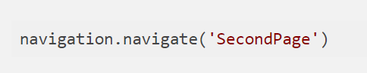

* navigation – the navigation prop is passed into every screen component in stack navigator
* navigate(‘SecondPage’) – we call the navigate function with the name of the route that we’d like to move the user to.

If we call navigation.navigate with a route name that we haven’t defined on a stack navigator, nothing will happen.

1. Navigate to a route multiple times

If you have any situation where you are on the SecondPage and have to open SecondPage again then you will see making navigation.navigate('SecondPage') the route will do nothing. It also makes sense for the normal case that why anybody wants to switch to the same screens? but for the special cases, they have provided navigation.push



push allows us to express the intent to add another route regardless of the existing navigation history. So even if you are on SecondPage you can push the SecondPage again.

1. Going back

The header provided by the stack navigator will automatically include a back button when it is possible to go back from the active screen (If there is only one screen in the navigation stack, there is nothing that you can go back to, and so there is no back button).

Sometimes you’ll want to be able to programmatically trigger this behavior, and for that, you can use

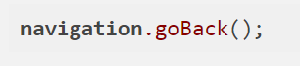

1. Go back to the first screen in the stack

If you want to go back to multiple screens, for example, if you are several screens deep in a stack and want to dismiss all of them to go back to the first screen of the stack then you can use



This will discard all the screens of the stack and will take you to the first screen in the stack.

1. Replace Screen in Stack

There are some cases which need to change the screen without keeping the last screen. For example, I have navigated to SecondPage from FirstPage and then want to navigate to ThirdPage but without keeping SecondPage in the Stack then I can use

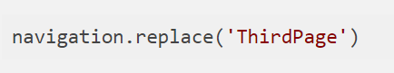

This will replace the SecondPage with the ThirdPage and will not keep SecondPage in the stack which means when we go back form the ThirdPage we will see FirstPage instead of the SecondPage.

1. Reset Navigator State

This is a bit different thing as all the above-mentioned navigation functions are to manage the different types of navigations but this function will help you to reset your navigation state in runtime. For example, If you want to land the user on different screens on the basis of different permissions then you can use this to reset the navigator.

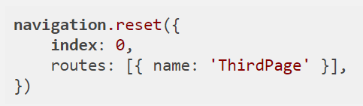

Here I have reset the ThirdPage as an initial page of the stack.